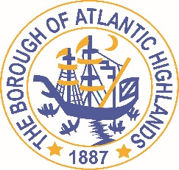

BOROUGH OF ATLANTIC HIGHLANDS
COUNTY OF MONMOUTH

RESOLUTION 008-2019

RESOLUTION AUTHORIZING THE AWARD OF A-NON-FAIR AND OPEN CONTRACT FOR professional services

WHEREAS, the Borough of Atlantic Highlands needs to employ Jeffrey R. Surenian Esq. to serve as Special Counsel on COAH matters, as a non-fair and open contract pursuant to the provisions of NJSA.19: 44A-20.2 et al; and,

WHEREAS, the terms of this contract terminate on December 31, 2019; and,

WHEREAS, Jeffrey R. Surenian and Associates, LLC has been assisting the Borough and its legal counsel in addressing the Borough’s responsibility with respect to its affordable housing obligations, and has been working on proceedings before the State of New Jersey & Superior Courts; and,

WHEREAS, Jeffrey R. Surenian and Associates, LLC has completed and submitted:
- Business Entity Disclosure Certification, form required pursuant to N.J.S.A. 19:44A-20.8, which certifies that Jeffrey R. Surenian and Associates, LLC has not made any reportable contributions to a political or candidate committee in the Borough of Atlantic Highlands in the previous one year, and that the contract will prohibit Jeffrey R. Surenian and Associates, LLC from making any reportable contributions through the term of the contract,
- Political Contribution Disclosure form required pursuant to N.J.S.A. 19:44A-1 et seq.
- Stockholder Disclosure Certification form required pursuant to N.J.S.A. 19:44A-20.8
- Iran Statement
- Certification of Compliance form required pursuant to Section 9-2.5 of the Revised General Ordinances of the Borough of Atlantic Highlands
- Valid New Jersey Business Registration Certificate pursuant to P.L. 2004, c.57

WHEREAS, Debra Latshaw-Adams, Acting Chief Financial Officer for the Borough of Atlantic Highlands, has certified that funds are available for this contract.

NOW THEREFORE, BE IT RESOLVED that the Governing Body of the Borough of Atlantic Highlands authorizes the Mayor and Borough Administrator to enter into a contract with Jeffrey R. Surenian and Associates, LLC at the rates established in his contract for professional services; and,

BE IT FURTHER RESOLVED, a notice of this action shall be printed once in an official newspaper of the Borough and that this Resolution and the contract shall be available for public inspection in the office of the Municipal Clerk.

Motion: Approve Resolution, Moved by Councilman Dellosso; Seconded by Councilman Fligor
Vote: Motion carried by roll call vote (summary: Yes = 5, No = 1).

Yes: Councilman Crowley, Councilman Dellosso, Councilman Fligor, Councilwoman Hohenleitner, Councilman Murphy
No: Councilman Boracchia
Abstain: None
Absent: None

I, Michelle Clark, Municipal Clerk of the Borough of Atlantic Highlands, in the County of Monmouth, State of New Jersey, hereby certify this to be a true copy of the action of the Governing Body, at its Reorganization Meeting, held January 1, 2019. WITNESS my hand this 2nd day of January 2019.
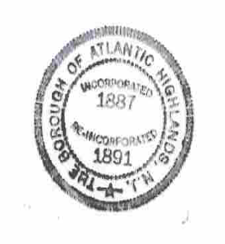
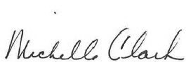
Michelle Clark, Municipal Clerk

