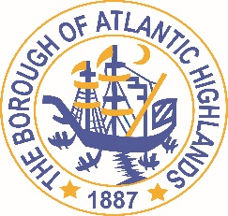
BOROUGH OF ATLANTIC HIGHLANDS
COUNTY OF MONMOUTH

RESOLUTION 053-2020

RESOLUTION AWARDING PROFESSIONAL SERVICE CONTRACT FOR REDEVELOPMENT COUNSEL

WHEREAS, there exists a need to appoint an individual or law firm to serve as redevelopment counsel to the Borough of Atlantic Highlands as a non-fair and open contract pursuant to applicable law; and

WHEREAS, the Local Public Contracts Law (N.J.S.A. 40A:11-5(1)(a)) does not require competitive bidding for this position; and

WHEREAS, subject to the certification of availability of funds by the Chief Financial Officer, Michael J. Lipari, Esq. of the law firm of Cutolo Barros LLC, 46-50 Throckmorton Street, Freehold, New Jersey 07728 has qualified, is in compliance with applicable law and has agreed to handle legal representation related to redevelopment of property located within the Borough as needed for 2020 at a rate of $140 per hour for, exclusive of fees for witnesses, experts, filing fees, title work, or other reasonable allowable expenses

NOW, THEREFORE, BE IT RESOLVED by the Borough of Atlantic Highlands in the County of Monmouth, State of New Jersey that Michael J. Lipari, Esq. of the law firm of Cutolo Barros LLC is hereby awarded a professional service contract for the provision of legal services as redevelopment counsel to the Borough as needed at the rate of $140 per hour (exclusive of allowable expenses) for 2020.

BE IT FURTHER RESOLVED that the Mayor and the Clerk are hereby authorized and directed to execute an Agreement for the provision of such professional services, a copy of which shall be maintained by the Clerk and advertised in the Borough’s official newspaper pursuant to law.

Motion: Approve Resolution Moved by Councilman Boms; Seconded by Councilman Crowley
Vote: Motion carried by unanimous roll call vote (summary: Yes = 6).

Yes: Councilman Boms, Councilman Boracchia, Councilman Crowley, Councilman Dellosso, Councilwoman Hohenleitner, Councilman Murphy
No: None
Absent: None

I, Michelle Clark, Municipal Clerk of the Borough of Atlantic Highlands, in the County of Monmouth, State of New Jersey, hereby certify this to be a true copy of the action of the Governing Body, at its Regular Meeting, held February 13, 2020. WITNESS my hand this 14th day of February 2020.
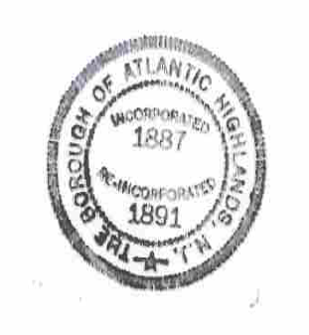
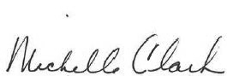
Michelle Clark
Municipal Clerk

