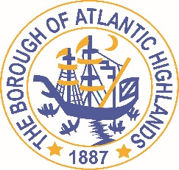
BOROUGH OF ATLANTIC HIGHLANDS
COUNTY OF MONMOUTH

RESOLUTION 010-2022

RESOLUTION AWARDING PROFESSIONAL SERVICE CONTRACT FOR REDEVELOPMENT COUNSEL

WHEREAS, there exists a need to appoint an individual or law firm to serve as redevelopment counsel to the Borough of Atlantic Highlands as a non-fair and open contract pursuant to applicable law; and

WHEREAS, the Local Public Contracts Law (N.J.S.A. 40A:11-5(1)(a)) does not require competitive bidding for this position; and

WHEREAS, subject to the certification of availability of funds by the Chief Financial Officer, Michael J. Lipari, Esq. of the law firm of Mandelbaum Salsburg PC, 3 Becker Farm Road, Suite 105, Roseland, New Jersey 07068 has qualified, is in compliance with applicable law and has agreed to handle legal representation related to redevelopment of property located within the Borough as needed for 2022 at a rate of $140 per hour for, exclusive of fees for witnesses, experts, filing fees, title work, or other reasonable allowable expenses

NOW, THEREFORE, BE IT RESOLVED by the Borough of Atlantic Highlands in the County of Monmouth, State of New Jersey that Michael J. Lipari, Esq. of the law firm of Mandelbaum Salsburg PC is hereby awarded a professional service contract for the provision of legal services as redevelopment counsel to the Borough as needed at the rate of $140 per hour (exclusive of allowable expenses) for 2022.

BE IT FURTHER RESOLVED that the Mayor and the Clerk are hereby authorized and directed to execute an Agreement for the provision of such professional services, a copy of which shall be maintained by the Clerk and advertised in the Borough’s official newspaper pursuant to law.

Motion: Approve Resolution 010-2022 Moved by Councilwoman Hohenleitner; Seconded by Councilman Murphy
Vote: Motion carried by roll call vote (summary: Yes = 6).

Yes: Councilman Boms, Councilman Boracchia, Councilman Crowley, Councilman Dougherty, Councilwoman Hohenleitner, Councilman Murphy
No: None
Abstain: None
Absent: None

I, Michelle Clark, Municipal Clerk of the Borough of Atlantic Highlands, in the County of Monmouth, State of New Jersey, hereby certify this to be a true copy of the action of the Governing Body, at its Reorganization Meeting held January 1, 2022. WITNESS my hand this 3rd day of January 2022.
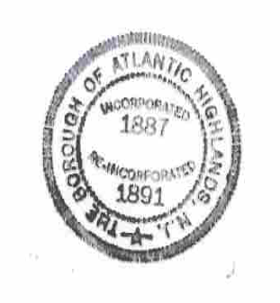
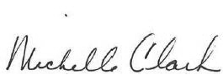
Michelle Clark
Municipal Clerk

