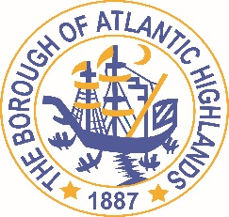
BOROUGH OF ATLANTIC HIGHLANDS
COUNTY OF MONMOUTH

RESOLUTION 018-2022

Authorizing award OF contract THROUGH A NON FAIR AND OPEN PROCESS for professional services pursuant to N.J.S.A. 19:44 a–20.4 et.seq

WHEREAS, there exists a need for a Financial Advisor for the Borough of Atlantic Highlands; and

WHEREAS, the terms of this contract will terminate on December 31, 2022; and,

WHEREAS, the Chief Municipal Financial Officer recommends that Phoenix Advisors LLC be appointed for the one-year term; and

WHEREAS, Phoenix Advisors LLC has completed and submitted:

- Business Entity Disclosure Certification form, required pursuant to N.J.S.A. 19:44A-20.8, which certifies that Phoenix Advisors LLC has not made any reportable contributions to a political or candidate committee in the Borough of Atlantic Highlands in the previous one year, and that the contract will prohibit Phoenix Advisors from making any reportable contributions through the term of the contract,
- Political Contribution Disclosure form required pursuant to N.J.S.A. 19:44A-1 et seq.
- Stockholder Disclosure Certification form required pursuant to N.J.S.A. 19:44A-20.8
- Iran Statement
- Certification of Compliance form required pursuant to Section 9-2.5 of the Revised General Ordinances of the Borough of Atlantic Highlands
- Valid New Jersey Business Registration Certificate pursuant to P.L. 2004, c.57

WHEREAS, Holman Frenia Allison, PC, Chief Financial Officer for the Borough of Atlantic Highlands, has certified that funds are or will be available for this contract.

NOW THEREFORE BE IT RESOLVED by the governing body of the Borough of Atlantic Highlands, County of Monmouth, State of New Jersey that Phoenix Advisors LLC is hereby appointed The Borough Financial advisor for the year 2022

BE IT FURTHER RESOLVED, a notice of this action shall be printed once in an official newspaper of the Borough and that this Resolution and the contract shall be available for public inspection in the office of the Municipal Clerk.

Motion: Approve Resolution Moved by Councilman Crowley; Seconded by Councilman Boms
Vote: Motion carried by roll call vote (summary: Yes = 6).

Yes: Councilman Boms, Councilman Boracchia, Councilman Crowley, Councilman Dougherty, Councilwoman Hohenleitner, Councilman Murphy
No: None
Abstain: None
Absent: None

I, Michelle Clark, Municipal Clerk of the Borough of Atlantic Highlands, in the County of Monmouth, State of New Jersey, hereby certify this to be a true copy of the action of the Governing Body, at its Reorganization Meeting held January 1, 2022. WITNESS my hand this 3rd day of January 2022.
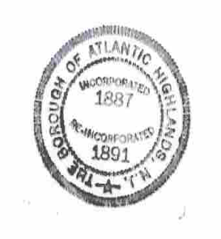
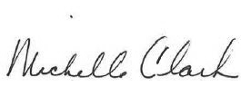
Michelle Clark, Municipal Clerk

