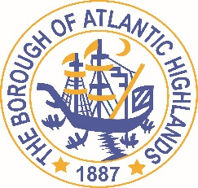
BOROUGH OF ATLANTIC HIGHLANDS
COUNTY OF MONMOUTH

RESOLUTION 151-2022

Authorizing award OF contract THROUGH A NON FAIR AND OPEN PROCESS for professional services pursuant to N.J.S.A. 19:44 a–20.4 et.seq

WHEREAS, there exists a need for a Financial Advisory Service for the Borough of Atlantic Highlands; and

WHEREAS, the terms of this contract will terminate on December 31, 2022; and,

WHEREAS, the Chief Municipal Financial Officer recommends that Holman Frenia Allison, P.C. (HFA) be appointed for the one-year term; and

WHEREAS, Holman Frenia Allison, P.C. (HFA) has completed and submitted:

- Business Entity Disclosure Certification form, required pursuant to N.J.S.A. 19:44A-20.8, which certifies that Holman Frenia Allison, P.C. has not made any reportable contributions to a political or candidate committee in the Borough of Atlantic Highlands in the previous one year, and that the contract will prohibit Holman Frenia Allison, P.C. from making any reportable contributions through the term of the contract,
- Political Contribution Disclosure form required pursuant to N.J.S.A. 19:44A-1 et seq.
- Stockholder Disclosure Certification form required pursuant to N.J.S.A. 19:44A-20.8
- Iran Statement
- Certification of Compliance form required pursuant to Section 15.15 of the Revised General Ordinances of the Borough of Atlantic Highlands
- Valid New Jersey Business Registration Certificate pursuant to P.L. 2004, c.57

WHEREAS, the Chief Financial Officer for the Borough of Atlantic Highlands, has certified that funds are or will be available for this contract in a monthly basis not to exceed $5,500 and department hourly rates as noted in contract

NOW THEREFORE BE IT RESOLVED by the governing body of the Borough of Atlantic Highlands, County of Monmouth, State of New Jersey that HFA is hereby appointed the Boroughs Financial Advisory Services for the remainder of the year 2022

BE IT FURTHER RESOLVED, a notice of this action shall be printed once in an official newspaper of the Borough and that this Resolution and the contract shall be available for public inspection in the office of the Municipal Clerk.

Motion: Approve Resolution Moved by Councilman Murphy; Seconded by Councilman Dougherty
Vote: Motion carried by roll call vote (summary: Yes = 6).
Yes: Councilman Murphy, Councilwoman Hohenleitner, Councilman Dougherty, Councilman Crowley, Councilman Boracchia, Councilman Boms
No: None
Absent: None

I, Michelle Clark, Municipal Clerk of the Borough of Atlantic Highlands, in the County of Monmouth, State of New Jersey, hereby certify this to be a true copy of the action of the Governing Body, at its Regular Meeting, held October 13, 2022, WITNESS my hand this 14th day of October 2022.
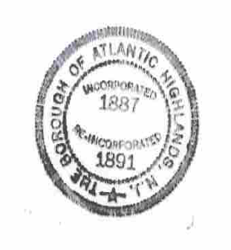
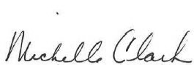
Michelle Clark, Municipal Clerk

