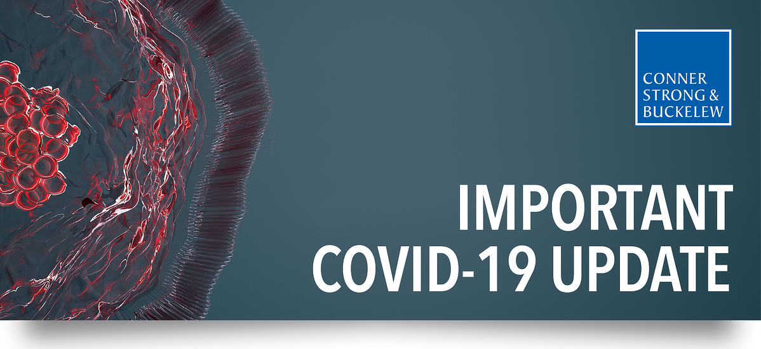

Small Business Association Launches Application & More on Additional Relief Under Cares Act
The Small Business Association has launched the COVID-19 ECONOMIC INJURY DISASTER LOAN APPLICATION.
Important: the typical requirement in the disaster loan program of demonstrating that you pursued an insurance claim has been removed. Therefore, you do not need to file an insurance claim as a precursor to the loan application.
The Treasury Department has announced that loans will be available as follows:
- April 3 for small businesses and sole proprietorship
- April 10 for independent contractors and employees
If you are looking for more information on eligibility for loans, tax credits available and other relief, below are several resources:
- Presentation prepared by the General Counsel to the Council of Insurance Agents and Brokers (CIAB).
- Information on Expansion of SBA Disaster Loan Program 15 U.S.C. 636(b)(2)
- FAQ prepared by Parker McCay
Please visit our COVID-19 Resource Center for all Conner Strong & Buckelew updates related to the coronavirus.

