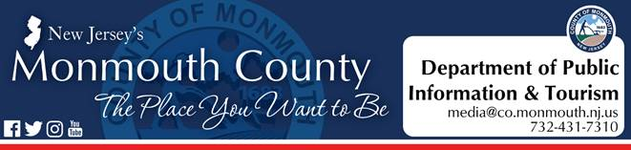

*For Immediate Release:*

**March 13, 2020**

**Monmouth County takes action in response**

**to COVID-19**

*Beginning Saturday, March 14, no public access to County buildings*

FREEHOLD, NJ –The Monmouth County Board of Chosen Freeholders and County officials are taking action out of an abundance of caution to protect and keep residents safe from the spread of the Coronavirus (COVID-19).

“Our number one priority is the safety of our residents and so, at this time, we have decided to take immediate actions to prevent the COVID-19 in Monmouth County libraries, parks and public buildings,” said Freeholder Director Thomas A. Arnone. “In attempt to curb the spread of COVID-19, Monmouth County will be suspending all public building access and programs beginning tomorrow.”

“We want to remind residents to remain calm and make sure you have the most accurate and up to date information, which you can get from the Centers of Disease Control or the New Jersey Department of Health. Please help us spread facts, not fear,” added Freeholder Director Arnone.

Beginning Saturday, March 14, and through Sunday, March 22, all Monmouth County Library branches and the Monmouth County Park System buildings will be closed to the public. County golf courses and park spaces will remain open.

Beginning Monday, March 16, public access will be restricted from all buildings with the exception of the Monmouth County Division of Social Services (MCDSS). For MCDSS, protections will be put into place to ensure that there is no physical contact between Monmouth County employees and the residents seeking services.

All Monmouth County employees will report to work and be available to residents by phone and by email.

“We understand that the COVID-19 situation is unsettling for some and want to arm our residents with the information they need,” said Freeholder Deputy Director Susan M. Kiley, liaison to the Monmouth County Department of Health and Human Services. “There is a Monmouth County Health Department’s phone bank will open Monday at 9 a.m. for residents who have any questions and concerns about COVID-19, or need to talk to someone about how this situation is affecting them.”

Crisis Counselors from the Monmouth County Division of Behavioral Health are available through the phone banks to help residents who may be experiencing stress or anxiety due to the evolving situation.  The counselors will provide County residents with guidance to help them through this challenging time.

The Monmouth County Health Department phone bank will open Monday, March 16 at 9 a.m. and can be reached at 732-845-2070.

#  #  #