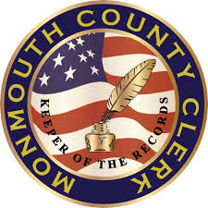
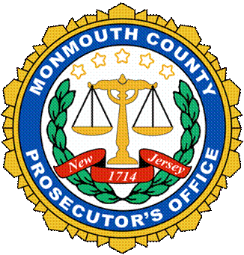

Monmouth County Prosecutor’s Office
Prosecutor Christopher J. Gramiccioni
Monmouth County Clerk’s Office
Monmouth County Clerk Christine Giordano Hanlon

For Immediate Release:
October 1, 2020
www.mcponj.org
www.MonmouthCountyClerk.com
pio@mcponj.org
jennifer.collins@co.monmouth.nj.us

CONTACT: Public Information Office
Charles Webster/Chris Swendeman
Desk: (732) 431-7160 ext. 7535/6468
Mobile: (732) 637-3382/ (732) 567-9768
Jennifer Collins/ 732-431-7324 x8735

Prosecutor’s Office and county elections offices
working to secure election integrity

FREEHOLD – Representatives from the Monmouth County Election Offices and Prosecutor’s Offices will be available to assist County voters with questions or issues that may arise with voting in this year’s general election, announced Monmouth County Clerk Christine G. Hanlon and Prosecutor Christopher J. Gramiccioni.
While November 3, 2020 is Election Day, the general election will primarily be conducted by mail-in ballots due to recent state mandates. According to the County Clerk, all active registered voters will receive a mail-in ballot for voting, per the recent state law. There will be a reduced number of polling locations across Monmouth County, with voting machine access available to voters who certify they have a disability and require access to a machine. On Election Day, all other voters will be offered provisional paper ballots for voting and will not be able to vote on voting machines.
Voters with questions about the process or drop box locations, or to find answers to frequently asked questions, can visit the county elections website at www.monmouthcountyvotes.com. Voters can also contact the County Clerk’s Office at 732-431-7790, the Superintendent of Elections at 732-431-7780 or the Board of Elections at 732-431-7802.
The County Clerk Office, The Board of Elections office and the Superintendent of Elections office all work in tandem to effectuate an election that is secure, reliable, accessible, free and fair so that all citizens can trust the process and the results. The County Clerk prepares and mails all of the ballots and certifies the election results. The Board of Elections receives and counts all paper ballots, and has jurisdiction over drop boxes, polling locations and poll workers. The Superintendent of Elections handles voter registration, voter history and all voting machines, and has an investigative unit to respond to complaints about the electoral process.

“Our democratic system of government depends on free and fair elections and, as such, election integrity and security is important to all of us,” said Prosecutor Gramiccioni and Clerk Hanlon. “For these reasons, our offices are working together to further safeguard the electoral process.”
Representatives from each Office will be available to respond to reports of possible fraud – examples which may include: voting in someone else’s name, registering to vote in multiple locations, voting by ineligible individuals, trying to vote more than one time, or paying or intimidating individuals to vote for certain candidates.
To report any issues of voter fraud or misconduct call the Monmouth County Prosecutor’s Office hotline at 855-786-5878.
# # #

