The following press release has been sent on behalf of the Monmouth County Board of Chosen Freeholders:

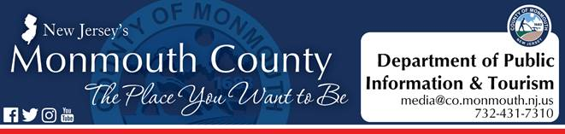

*For Immediate Release:*

**March 16, 2020**

**Monmouth County has 14 positive cases of COVID-19**

FREEHOLD, NJ –Monmouth County Freeholder Director Thomas A. Arnone and Freeholder Deputy Director Susan M. Kiley have announced that, as of 10 a.m. this morning, there are 14 positive cases of COVID-19 in Monmouth County.

As more information becomes available, it will be shared with the public and the media. News updates and information regarding County events and programs affected by the COVID-19 situation are posted at [www.visitmonmouth.com](https://co.monmouth.nj.us/page.aspx?ID=5012&mode=1).

“The Board of Chosen Freeholders is working, in conjunction with the Monmouth County Health Department and the Office of Emergency Management, with State partners to respond to and mitigate this evolving situation,” said Freeholder Director Thomas A. Arnone. “Please remember that the best defense against COVID-19 is to practice safe respiratory hygiene and take steps to prevent the spread of germs including practicing social distancing, staying home when sick, washing hands and covering coughs and sneezes.”

As of Saturday, March 14, all Monmouth County Library branches and the Monmouth County Park System will are currently closed to the public. County golf courses and park spaces remain open.

As of today, Monday, March 16, public access will be restricted from all buildings with the exception of the Monmouth County Division of Social Services (MCDSS). For MCDSS, protections have been put into place to ensure that there is no physical contact between Monmouth County employees and the residents seeking services.

All Monmouth County employees are available to residents by phone and by email.

“Please remember that your mental health is just as important as your physical health,” said Freeholder Deputy Director Susan M. Kiley, liaison to the Departments of Health and Human Services. “If you, or someone you know, are struggling with dealing with this unprecedented situation, please call the crisis counselors available at the County’s Health Department hotline.”

Crisis counselors from the Monmouth County Division of Behavioral Health are available through the phone banks to help residents who may be experiencing stress or anxiety due to the evolving situation.  The counselors will provide County residents with guidance to help them through this challenging time.

The Monmouth County Health Department phone bank is now open weekdays from 9 a.m. to 8 p.m. and can be reached at 732-845-2070.

#  #  #

Tricia Ring Wajda

Director of Public Information & Tourism

Monmouth County

Hall of Records Annex

1 East Main Street, Freehold

[tricia.wajda@visitmonmouth.com](mailto:tricia.wajda@visitmonmouth.com)

732-431-7310, ext. 7318